Lab 2.2 Write Up

$φ_{R}=\frac{1}{2r}(2\dot{X_{r}}+ \dot{θd)}$

$φ_{L}=\frac{1}{2r}(2\dot{X_{r}}- \dot{θd)}$

1. We used the following from the book in our code:

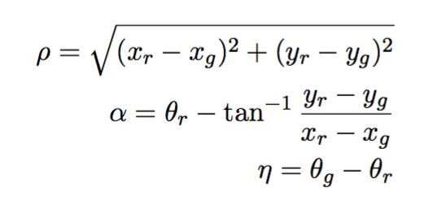

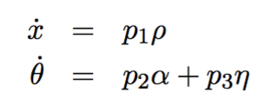

If we decrease our constants, the wheel speed would be slower than with the original 0.1 constant, and Sparki would reach the destination much slower than necessary. On the other hand, if we increased our constants, the wheel speed would increase, and the remaining angle/distance to the destination point could be calculated too late, which means Sparki would miss the destination point (an overestimate). If the constants we use got too big, Sparki would first over estimate the destination, and miss the finishing point, recalculate and then miss the point again on the way back. Sparki would spiral toward the destination point without reaching it. The 0.01*(THETA-theta_r) term is a measurement of your current heading, which is the direction Sparki is facing. This measurement allows Sparki to follow a designated curvature path that gets Sparki to the correct destination with the desired orientation.